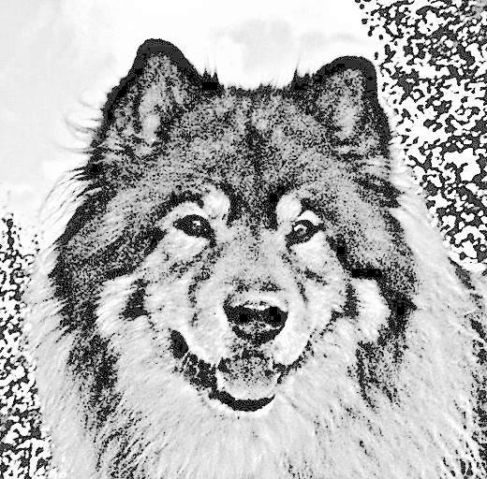
NGEH
Nordic Group for Eurasier Health

Health and Properties Form for Eurasiers ( please fill out one form for every dog )

Dog Name: |  | Born: |  | ChipNr:
female male | Color:
Hight: |  |  | Weight:

HD | Grade A B C D E
ED / AD | Grade 0 1 2 3 4 ( = FPCM, LPA, OC )
PL | Grade 0 1 2 3 4 ( should be testet when dog is awake! )
Distichiasis | No Yes 1-4 eyelashes arranged in two raws many eyelashes arranged in two raws
Kinky tale | No Yes
Stomach rotation | No Yes
Cryptorchidism | testicles fully descended No Yes
Diabetes | No Yes
EPI | Pancreas hypofunction No Yes
Hypothyreoidism | Thyroid hypofunction No Yes  date of examination: values: T4: fT4: TSH: TgAA: neg.: pos.:
Umbilical hernia | No Yes
Pigmentation | Nose: ok deficient Lipps: ok deficient Paws/Nails: ok deficient
Ears | in which age straightend they up?: < 3 months, 3-6 months > 6 months never
Entropium | No Yes
Ectropium | No Yes
Tumor | No Yes if yes, which kind of:
Bite | scissor pincer (level bite) undershot (underbite) overshot (overbite)
Set of Teeth | missing teeth: No Yes if yes, which ones:

Informations according to the IFEZ-database:

Diseases:

chron. skindiseases | No Yes | eczemas | No Yes
chron. digestiondiseases | No Yes | chron. lamenesses | No Yes
chron. airwaydiseases | No Yes | heartdiseases | No Yes
Other:

Charakter:

Hunting instinct | none some middel strong
Behaviour towards people | friendly searches contact reserved shy aggressiv
Behaviour towards other dogs | towards females: friendly aggressiv towards males: friendly aggressiv
Temperament | calm lively nervous
Remarks,Others:

Exterior:

Give an opinion of your dog, is he more: fine or substantial or average
Please send us good pictures of your dog standing from the side and the front and if you have, judge`s reports with good descriptions.
Remarks,Others:

I want the following club to enter the required dates of my dog in the IFEZ-database:
The eurasier breed club of my country ( if IFEZ-member) The NGEH

Location: Date: Signature:

