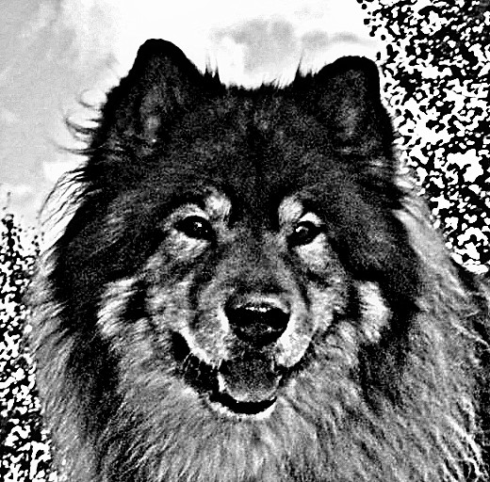
Nordic Group for Eurasier Health

Application Send application to: Bettina Franz, Odalsvegen 534, 2330 Vallset, Norway
( Please print clearly ) E-Mail: eurasier@gmx.ch

First and Last-Name
Address
Postcode/City
Country
Phone No. private Mobile
E-Mail
Homepage
Number of Eurasiers, sex and age

For breeders: Kennel Name:
How many litters do you have in a year?:

What FCI/FCI-recognized club are you a member of?

By signing this application and upon receipt of the confirmation of membership in the NGEH I agree to
always, without delay, provide information on my Eurasier(s) to the responsible representative of the
NGEH as required by the rules of the NGEH. The NGEH may enter this data into its own data base as well
as into the IFEZ Database. (For breeders this also includes information on puppies that were previously
sold). I support the ideals of this group.
I will do my best to obey the NGEH rules and the NGEH breeding recommendations and may, in return,
receive information submitted by other NGEH members. I am aware that the data is sole property of the
NGEH and that I may neither publish nor pass it on to third parties.

As a member I can participate in NGEH activities on a preferred basis and for a lower fee.
I am aiming at an open and honest communication with other NGEH members to protect the health of
our Eurasiers and to enforce the FCI Eurasier standard No. 291 as the only standard of excellence by
which the Eurasier shall be bred.

Location: Date: Signature:

I agree with the writing of my name under "Signature" that I want to be a member of the NGEH

‼ The membership is provisional and will only be confirmed once:
- the basic information of the dog(s) owned by the applicant(s) were submitted
to the NGEH (see separate questionnaire)
- the main representative of the NGEH or the representative of the country have
approved the membership.

